St. Francis Institute of Technology, Mumbai-400 103

**Department Of Information Technology**

A.Y. 2024-2025

Class: TE-ITA/B, Semester: V

Subject: **DevOps Lab**

**Experiment – 4: To understand Continuous Integration, install and configure Jenkins with Maven/Ant/Gradle to setup a build Job.**

1. **Aim:** To understand Continuous Integration, install and configure Jenkins with Maven
2. **Objectives:** Aim of this experiment is that, the students will be able

* To Integrate and deploy tools like Jenkins and Maven, which is used to build

applications in DevOps environment

1. **Outcomes:** After study of this experiment, the students will be able

* To understand the importance of Jenkins to Build and deploy Software

Applications on server environment.

* Learn about Jenkins (With Architecture)
* To have introduction to Maven / Gradle / Ant

1. **Prerequisite:** Knowledge of software engineering concept of integration
2. **Requirements:** Jenkins,JDK, python, ANT,Personal Computer, Windows operating system, browser, Internet Connection, Microsoft Word.
3. **Pre-Experiment Exercise:**

**Brief Theory:** Refer shared material

1. **Laboratory Exercise**
   * + 1. **Procedure:**

**a. Answer the following:**

* What is Jenkins?
* Why use Jenkins?

**b**. **Execute following (Refer the shared material) and attach screenshots:**

* Install Jenkins
* Configure Jenkins with Maven and ANT
* Build 4 basic projects in Jenkins

1. **Post-Experiments Exercise**
2. **Extended Theory:**

Nil

1. **Questions:**

* What are the system requirements to install Jenkins?
* Give some important plugins in Jenkins.
* What is Maven and ANT?

1. **Conclusion:**

* Write what was performed in the experiment.
* Write the significance of the topic studied in the experiment.

1. **References:**

<https://jenkins.io/doc/>

<https://www.cloudbees.com/jenkins/what-is-jenkins>

<https://vmokshagroup.com/blog/what-is-jenkins/>

<https://www.infoworld.com/article/3239666/what-is-jenkins-the-ci-server-explained.html>

<https://hackr.io/blog/jenkins-interview-questions>

**JENKINS INSTALLATION:**

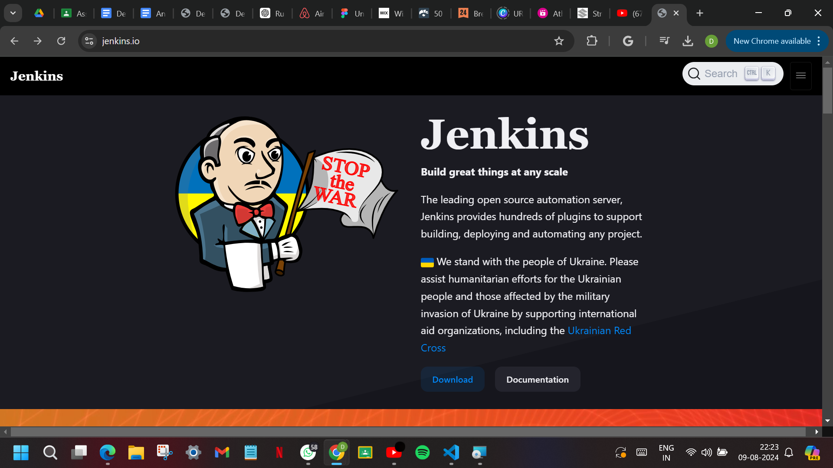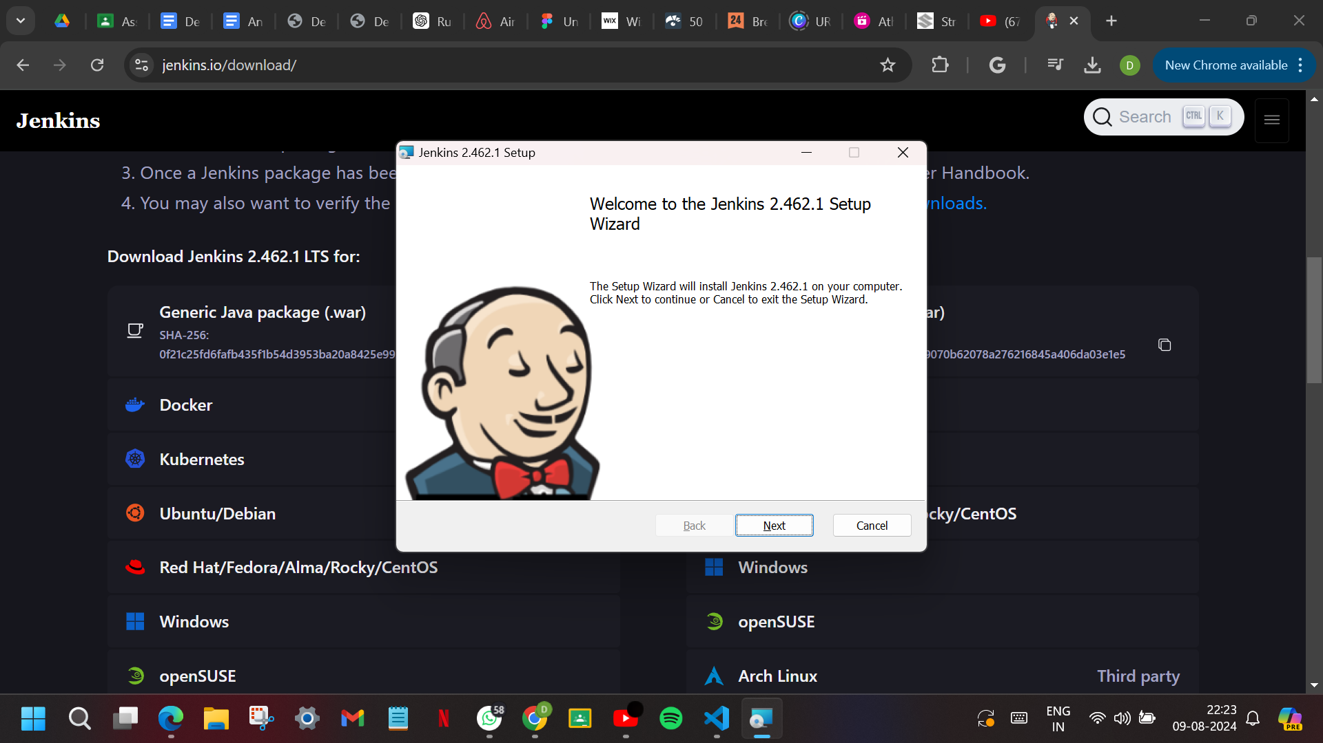 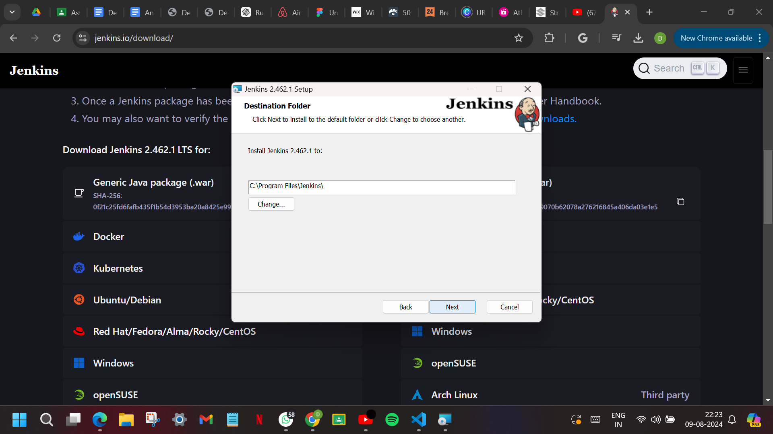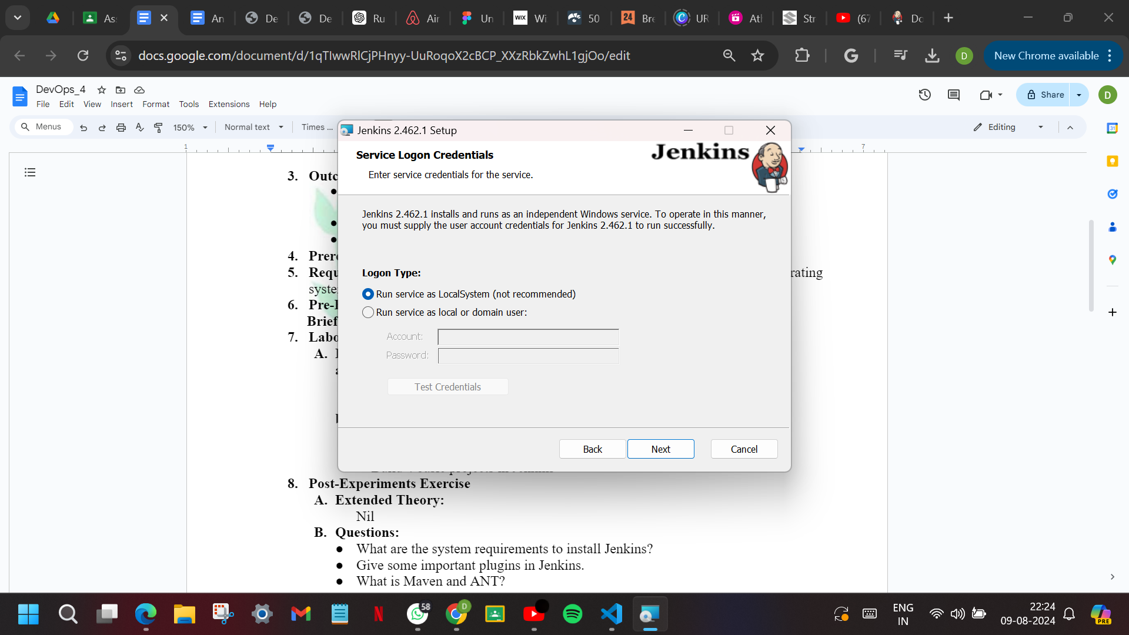 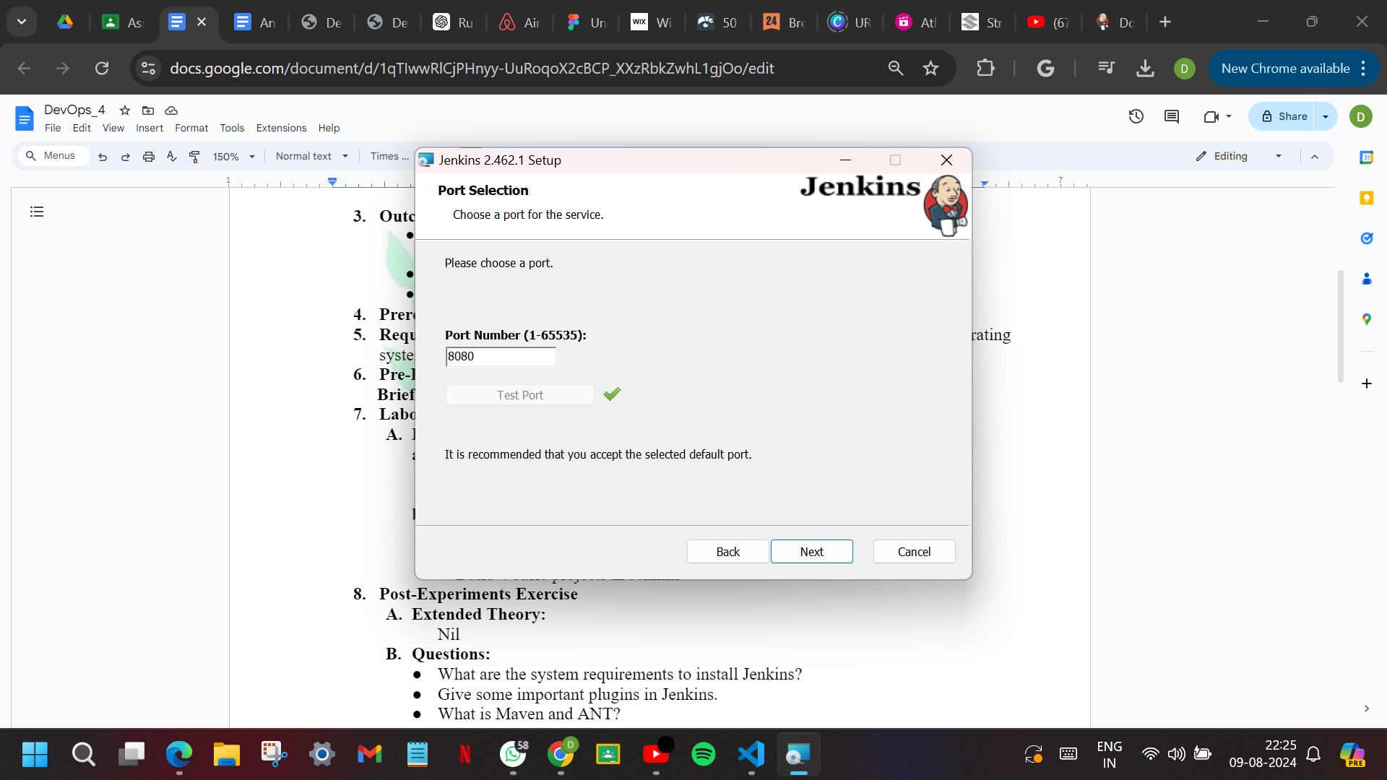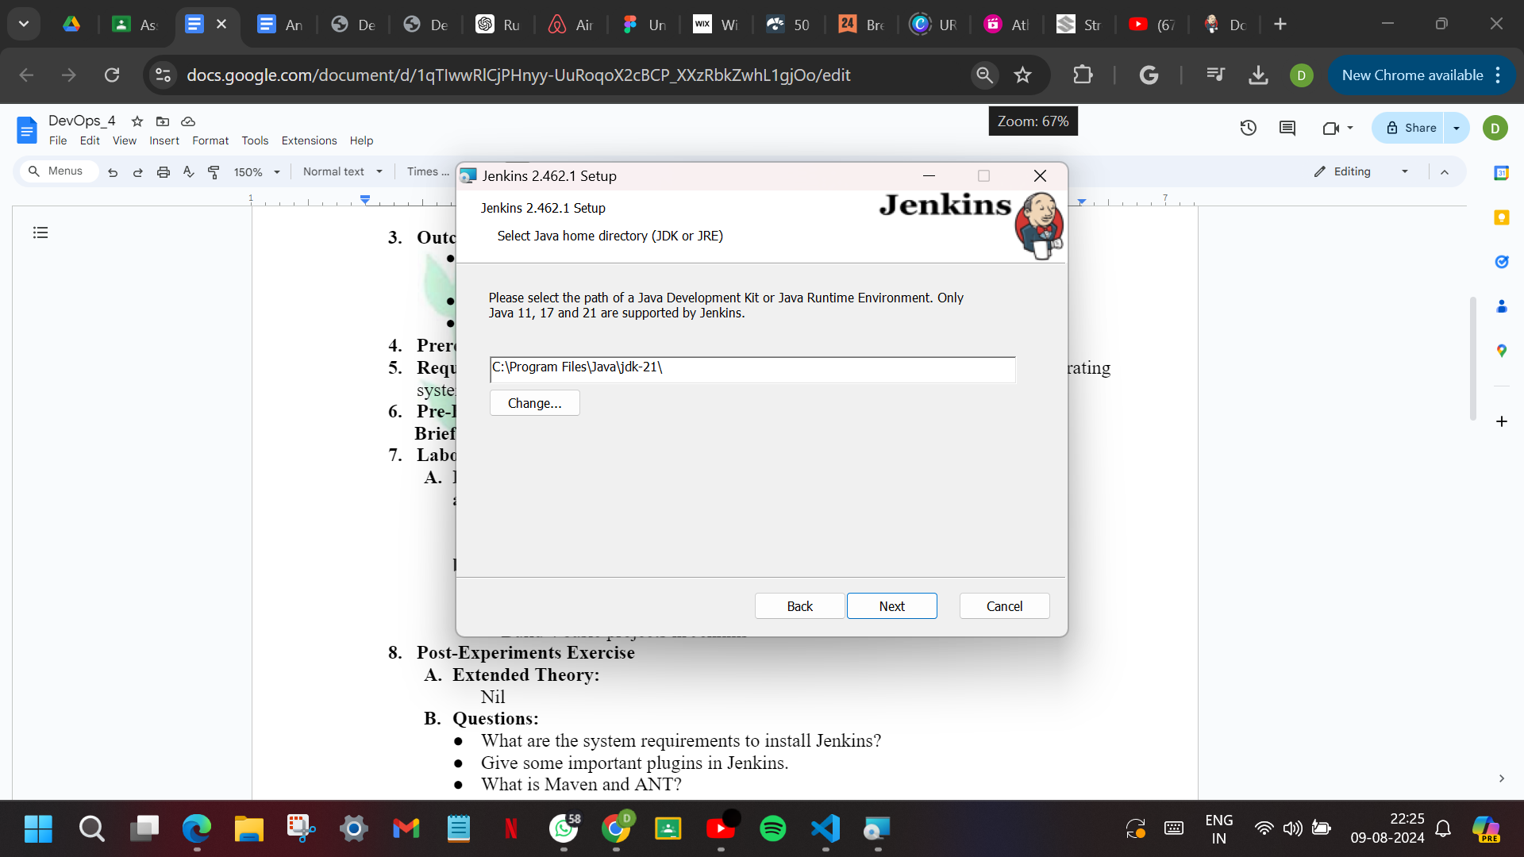 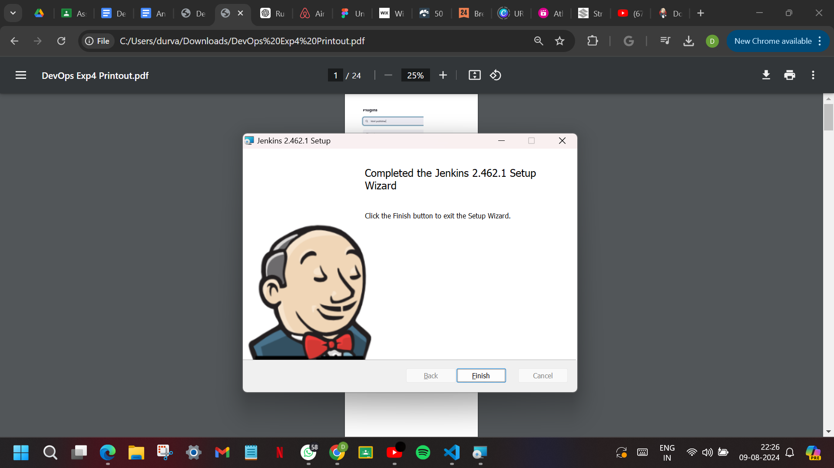

**CONFIGURATION:**

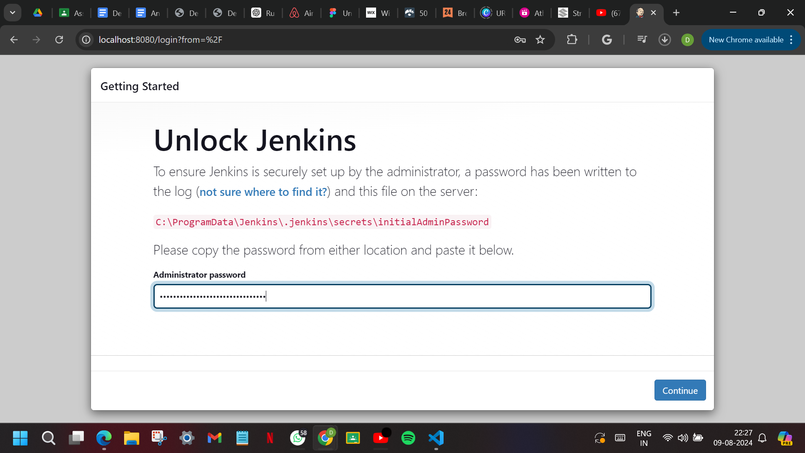

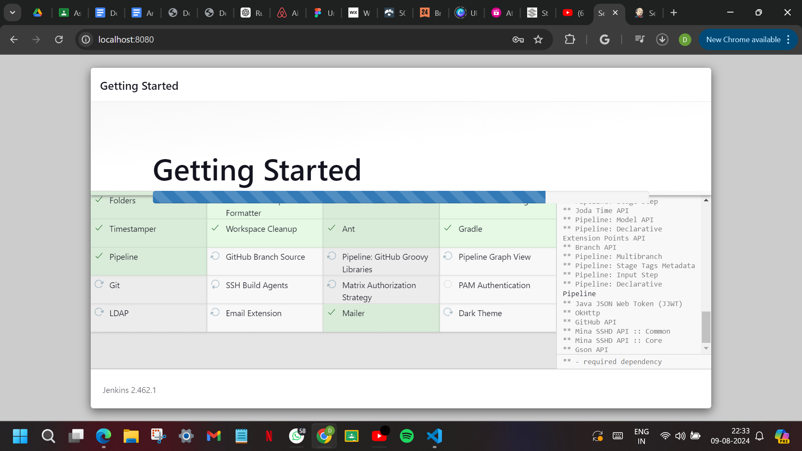

Here, we created our first admin user and set a username and password for future logins.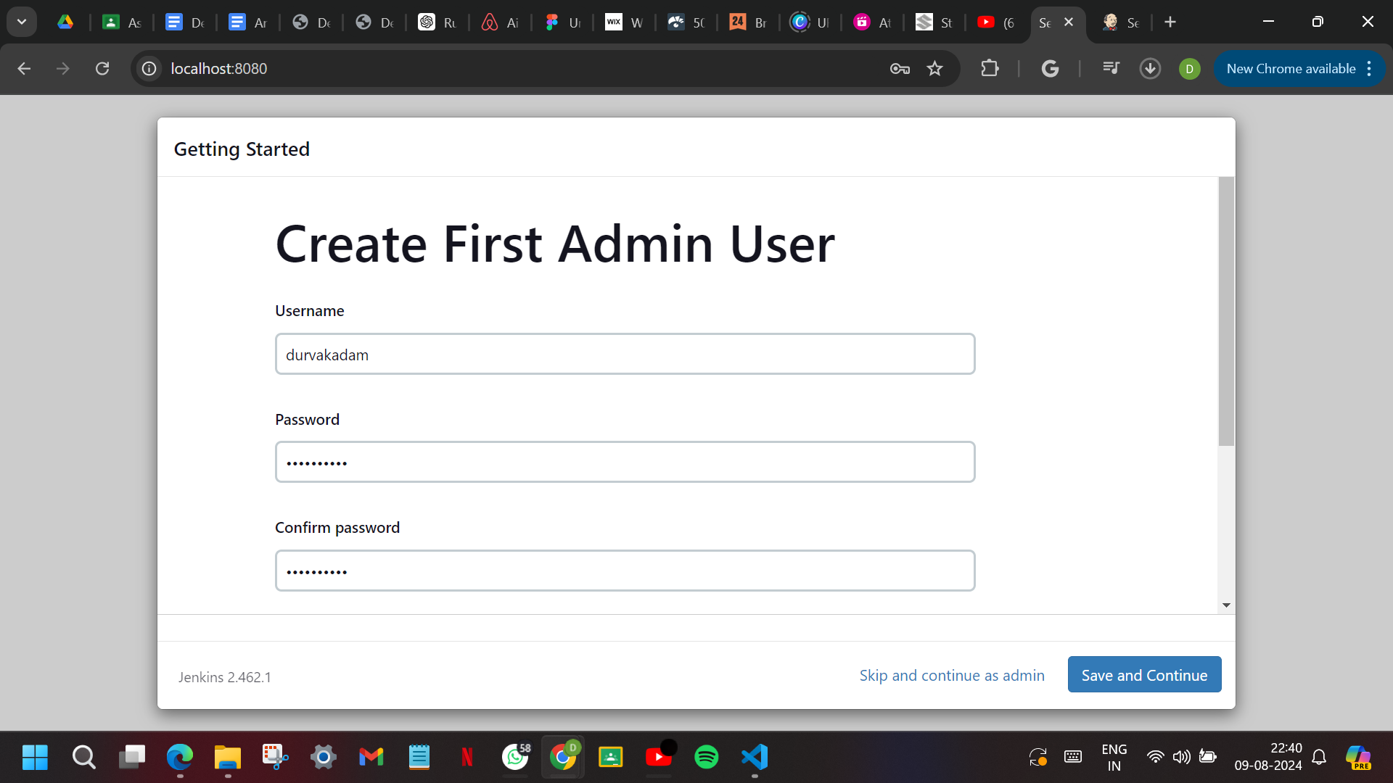

Then, we set a root url for Jenkins.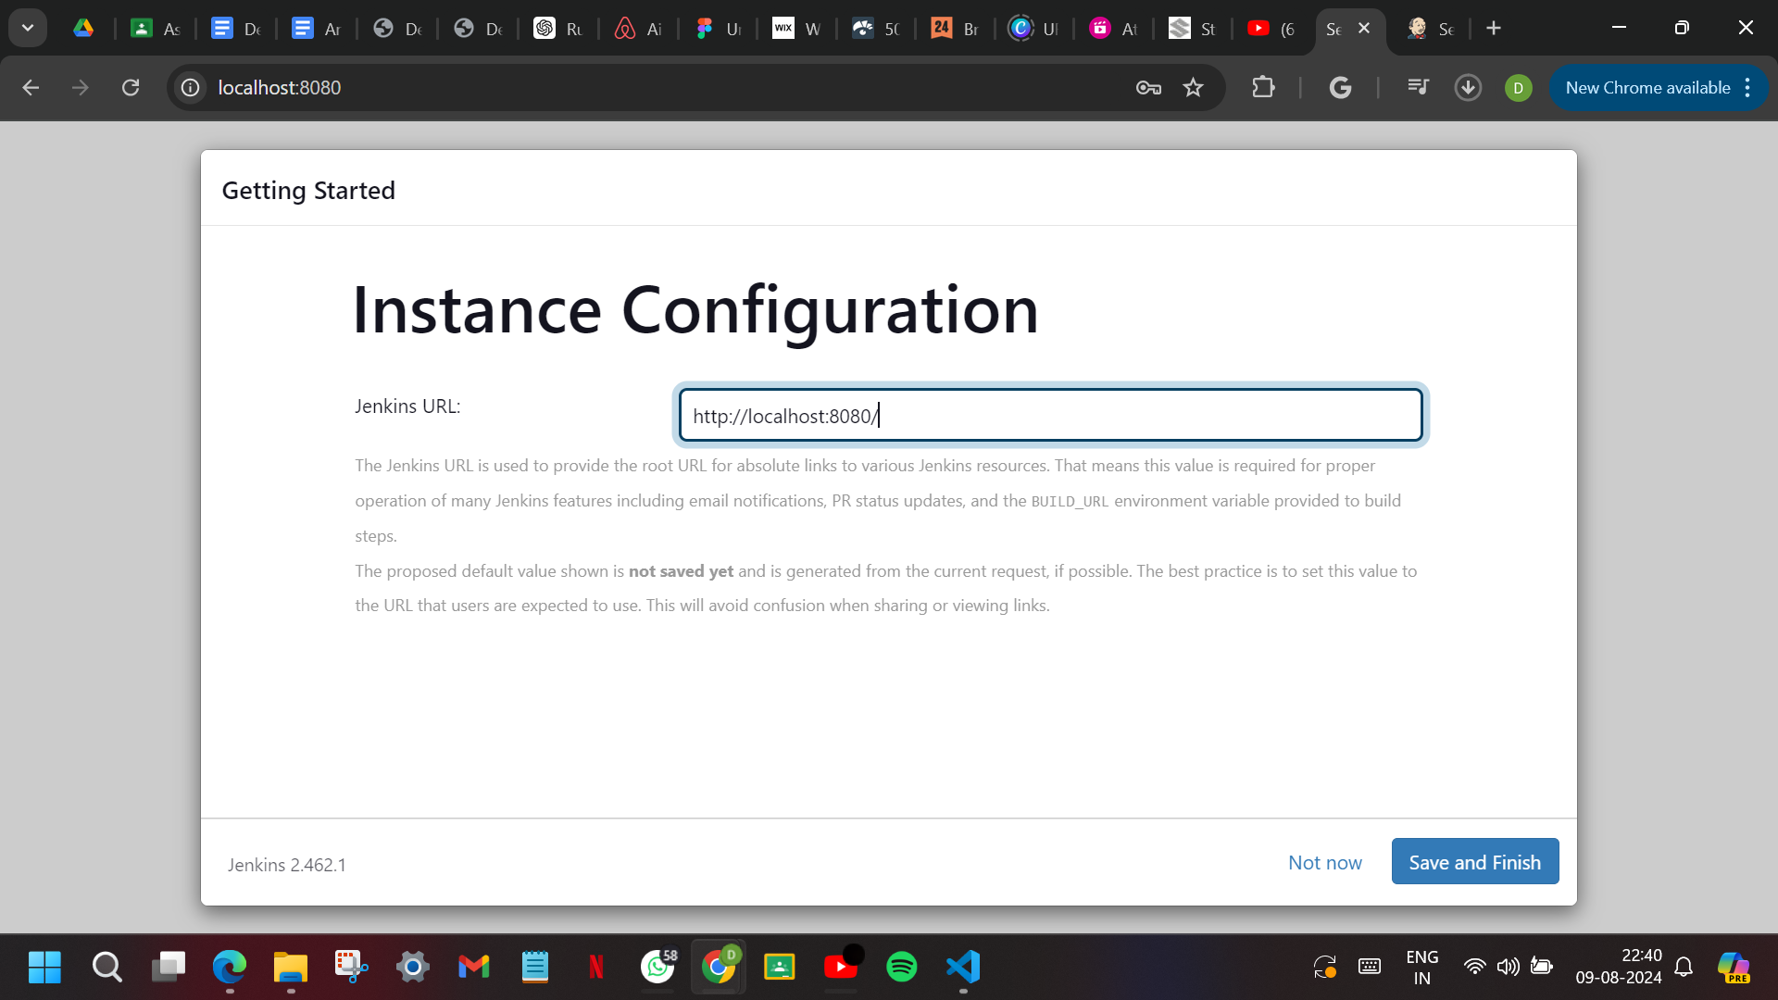

Jenkins setup is ready.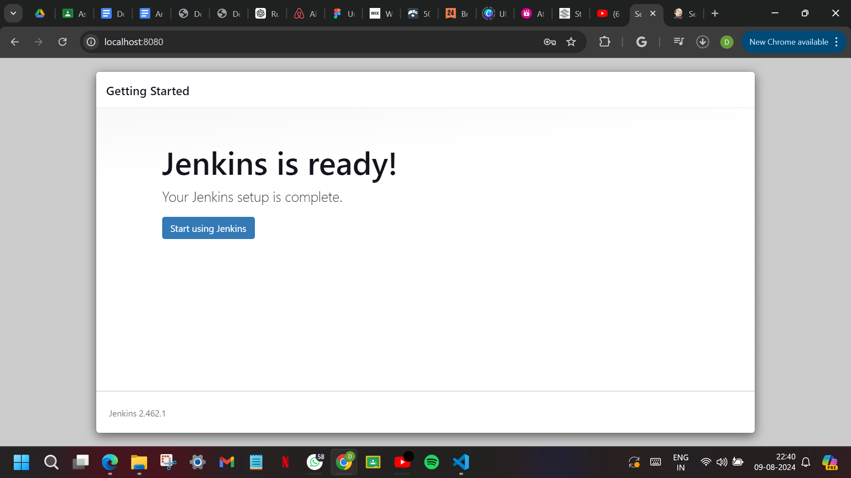

This is the Jenkins interface where we can install more plugins and build projects.

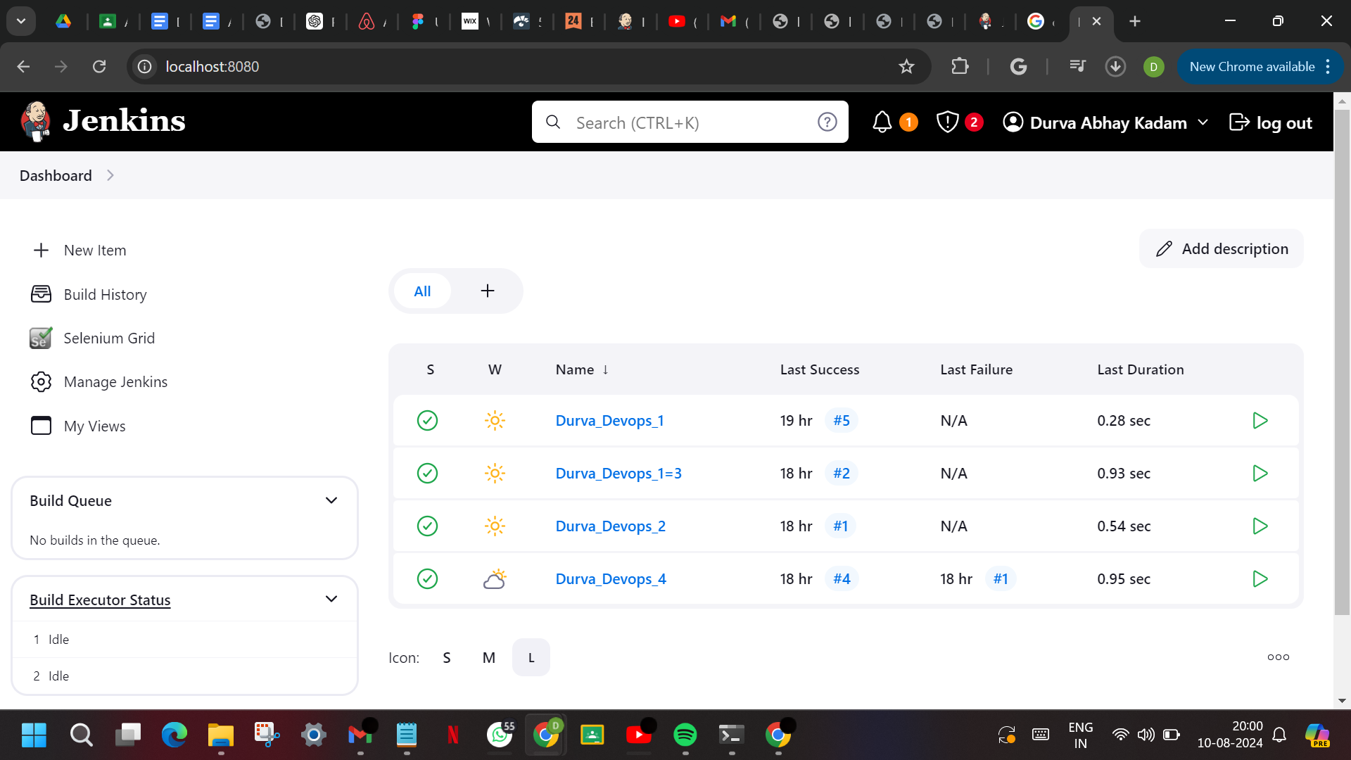

**Installed Plugins:**

1. **Python:**

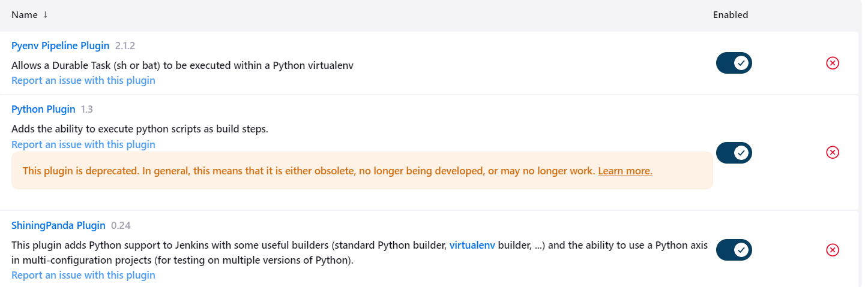

1. **HTML Publisher:**

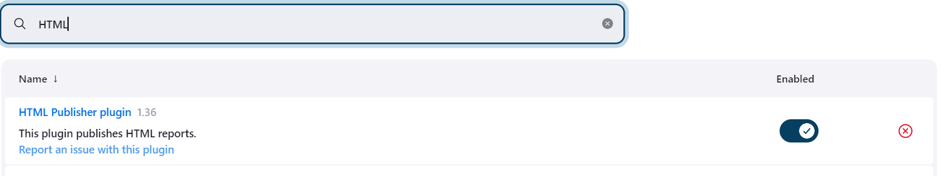

**3. MAVEN:**

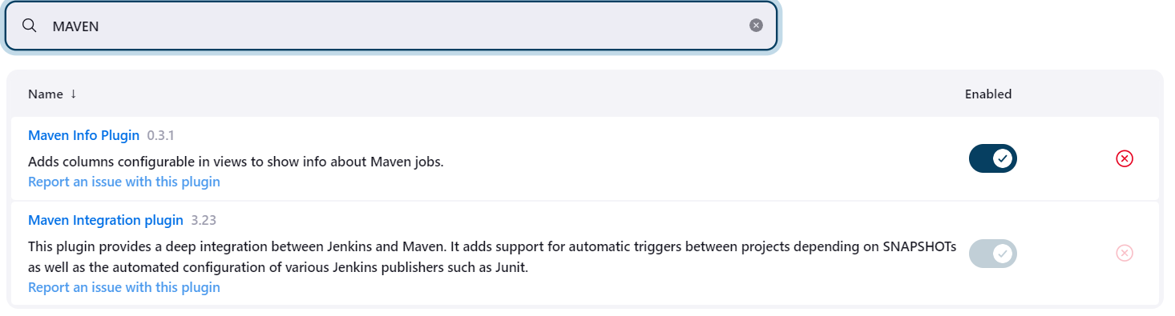

**4. SELENIUM:**

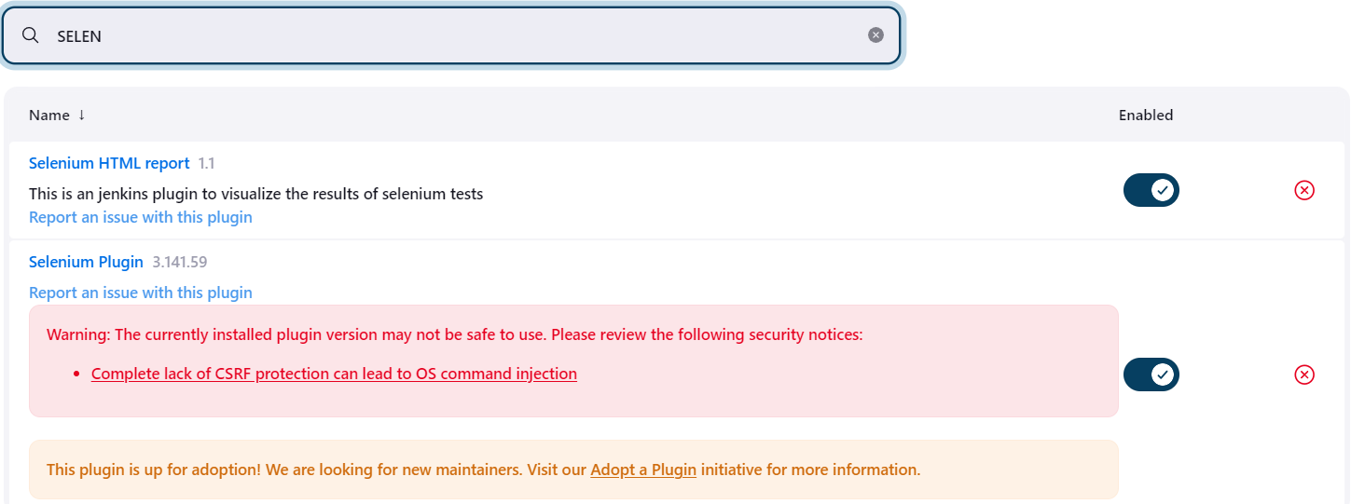

**5. DOCKER:**

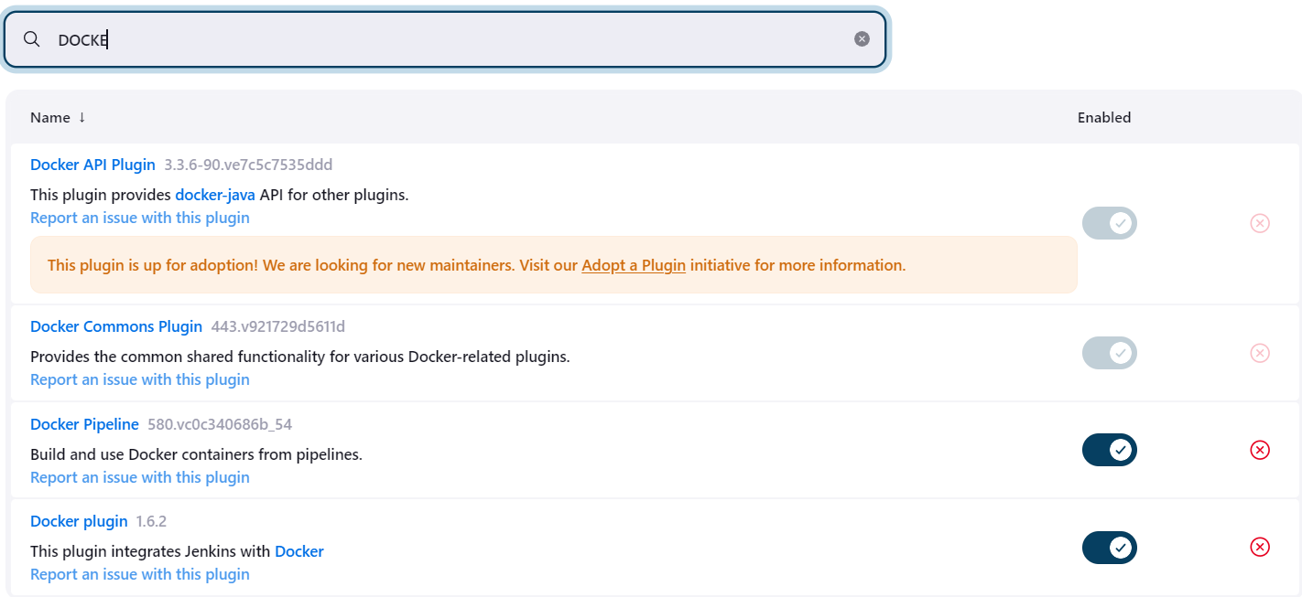

**6. BUILD PIPELINE:**

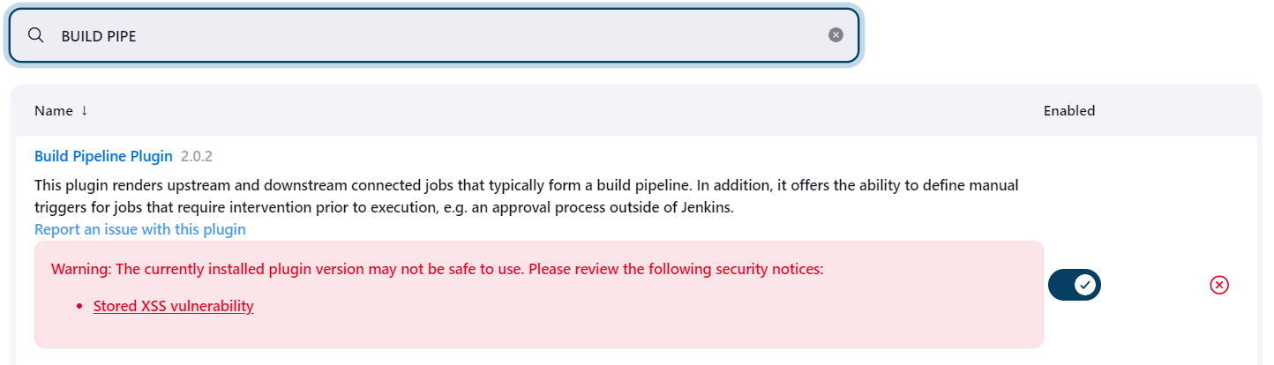

**Tools Installation:**

**1. JDK:**

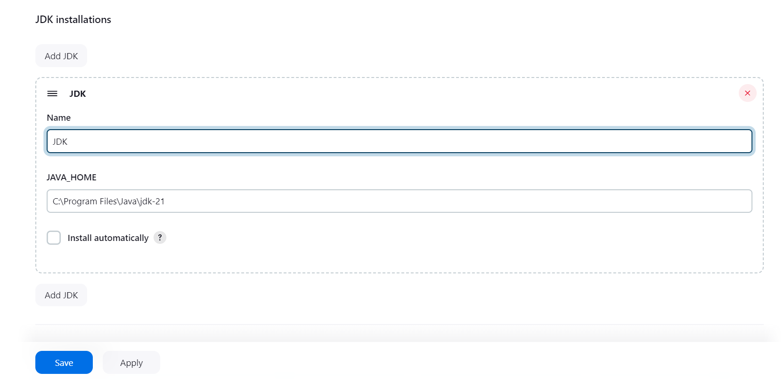

**2. GIT:**

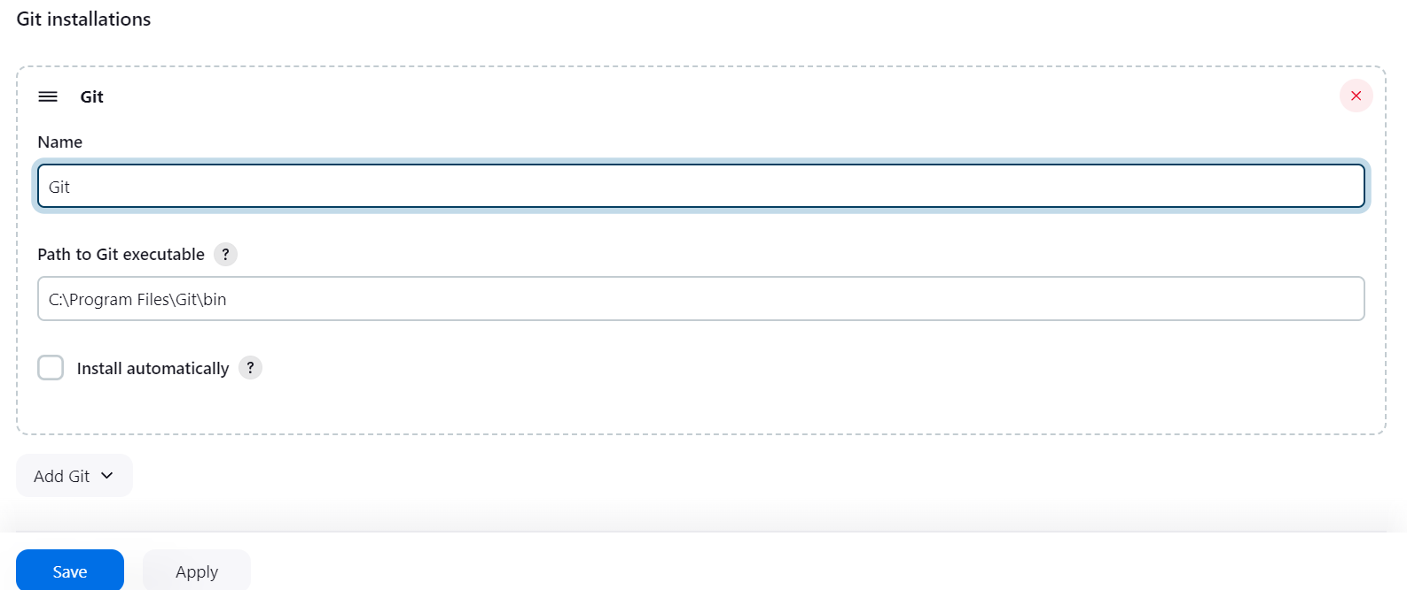

**3. GRADLE:**

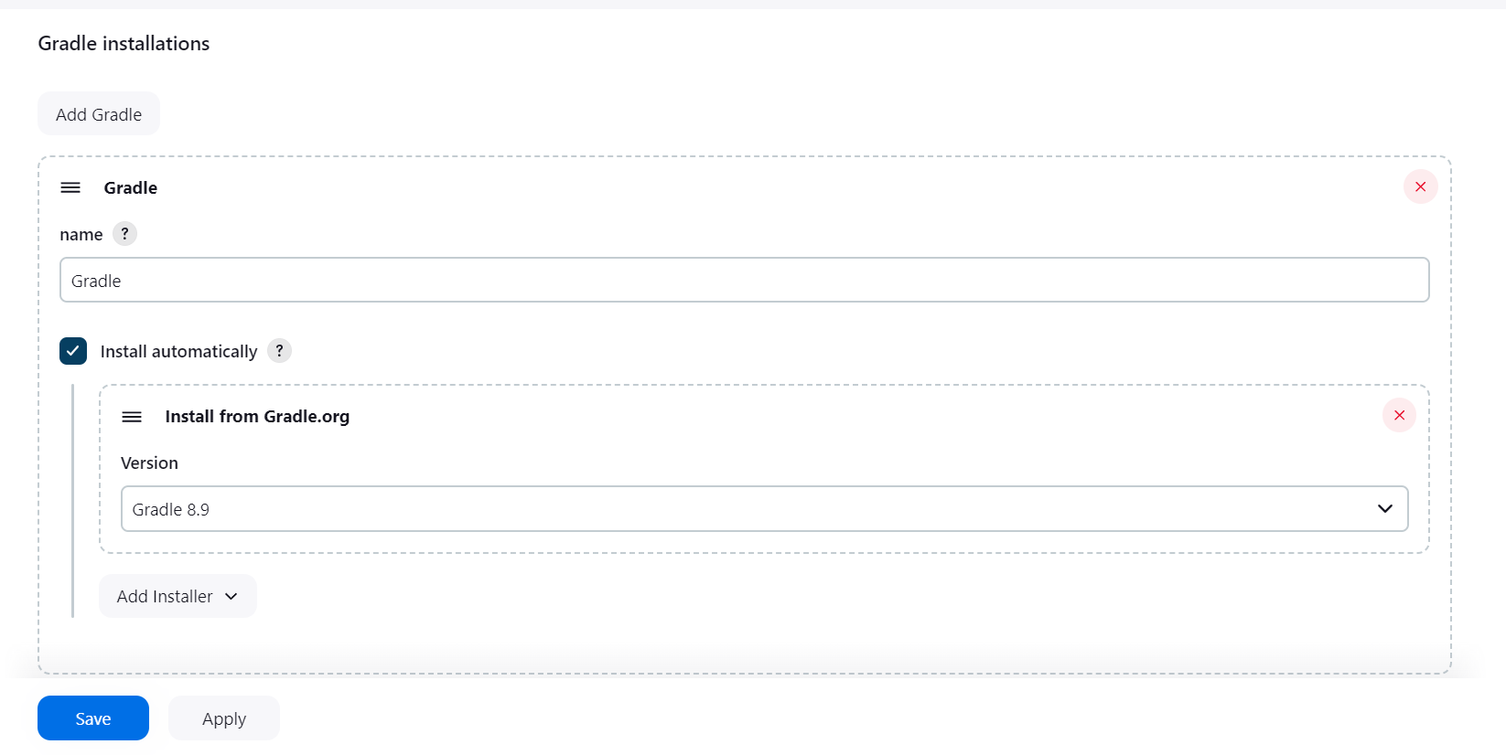

**4. ANT:**

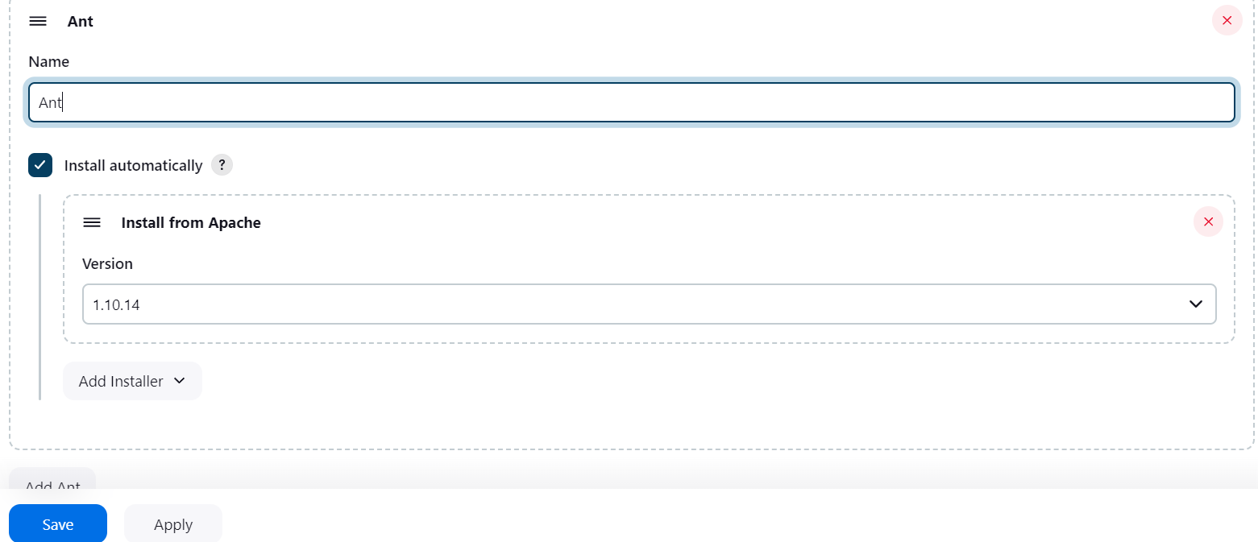

**5. MAVEN:**

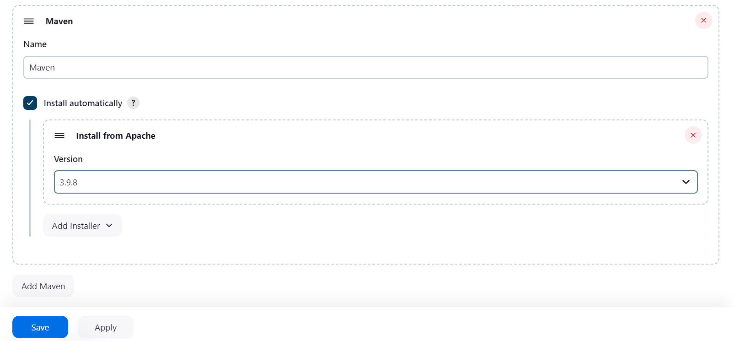

**6. PYTHON:**

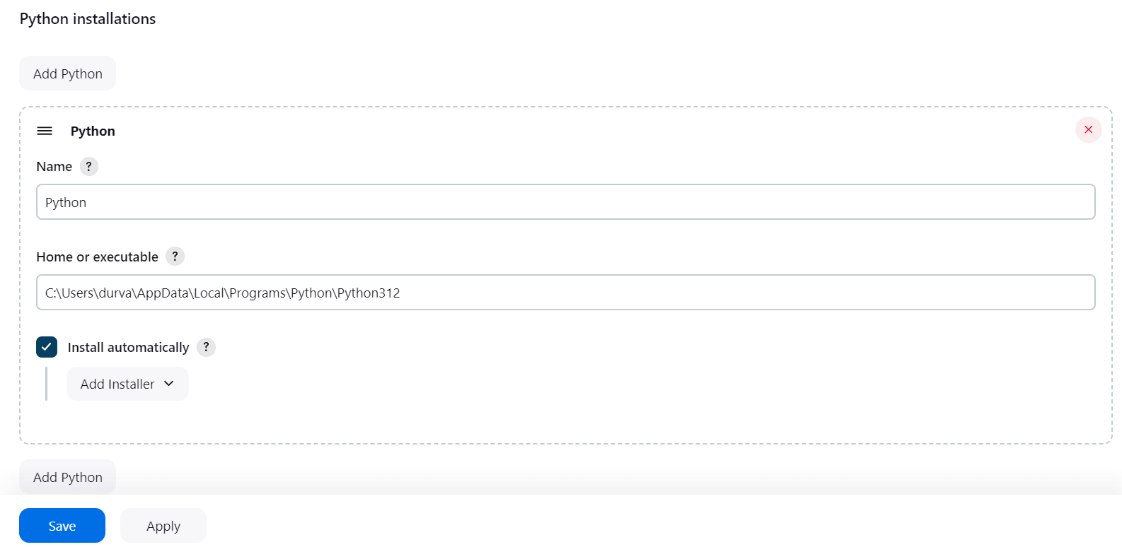

**Creating a new freestyle project:**

**PROJECT - 1:**

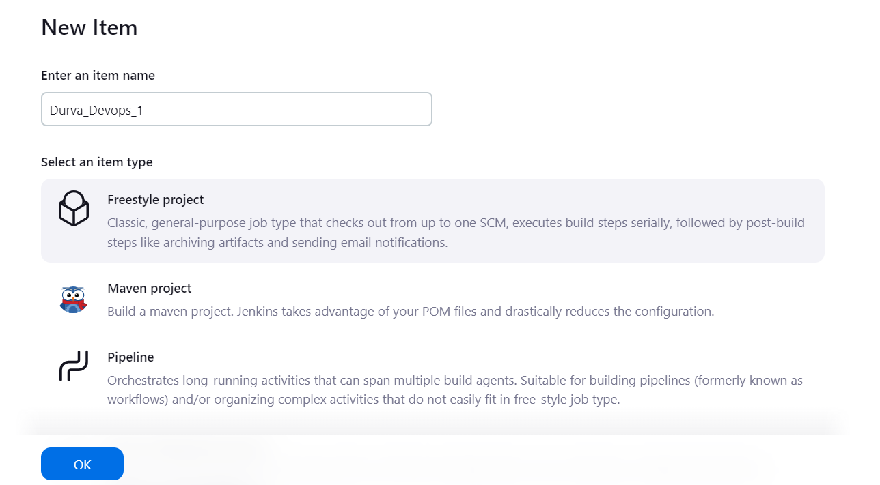 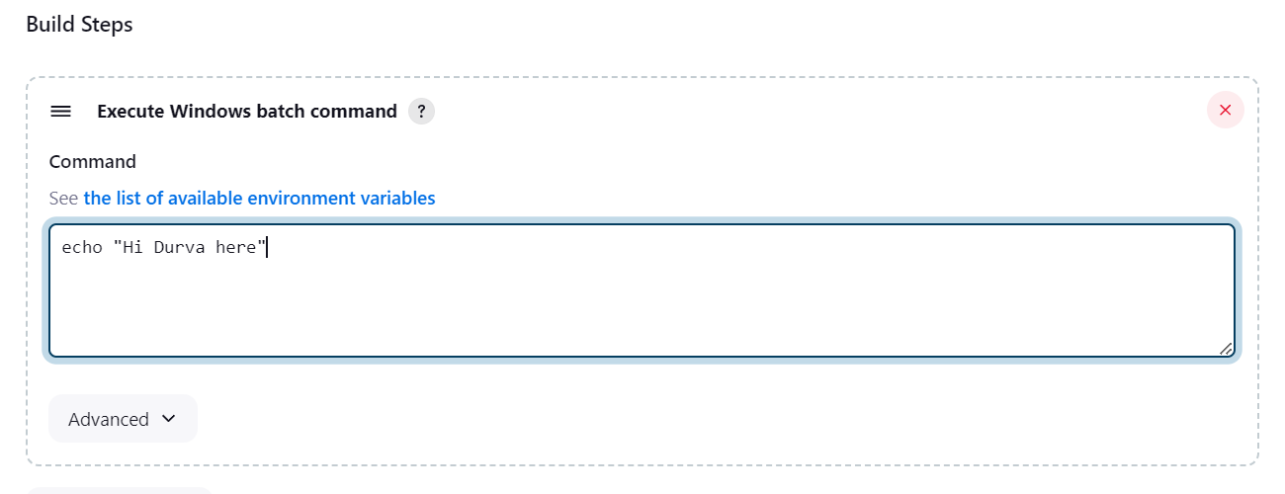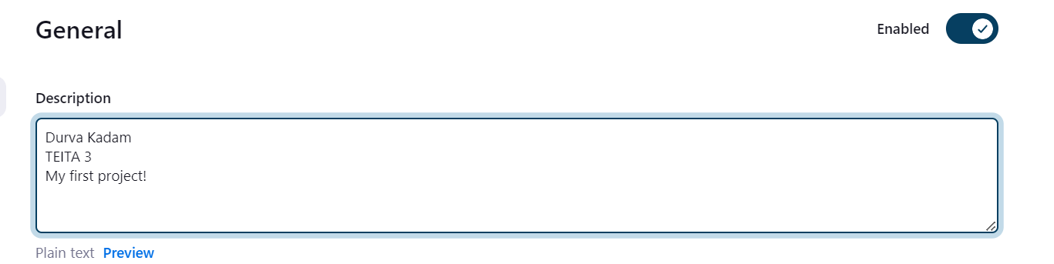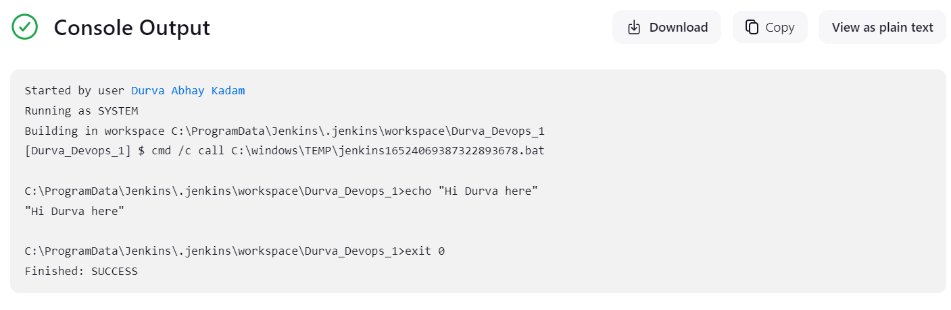

**PROJECT - 2:**

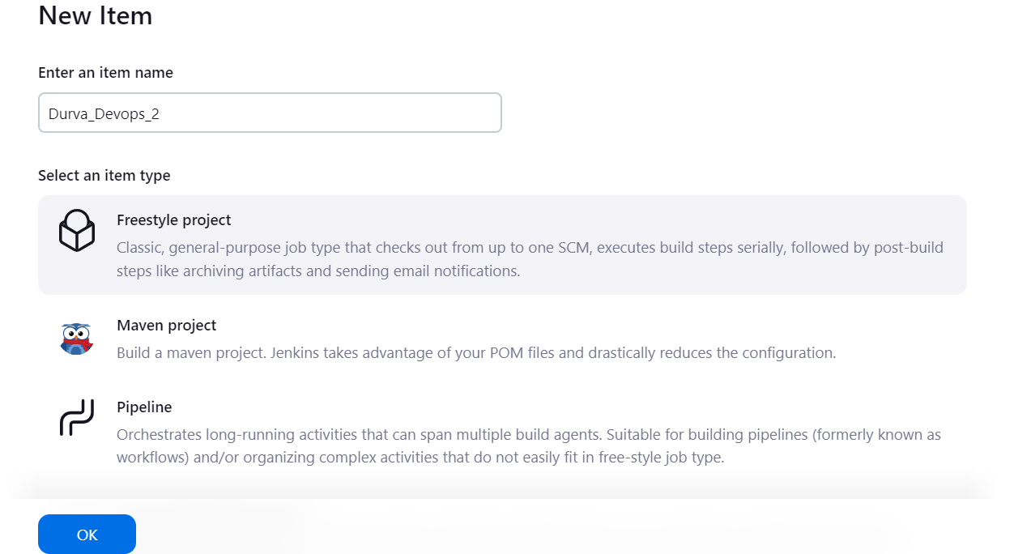

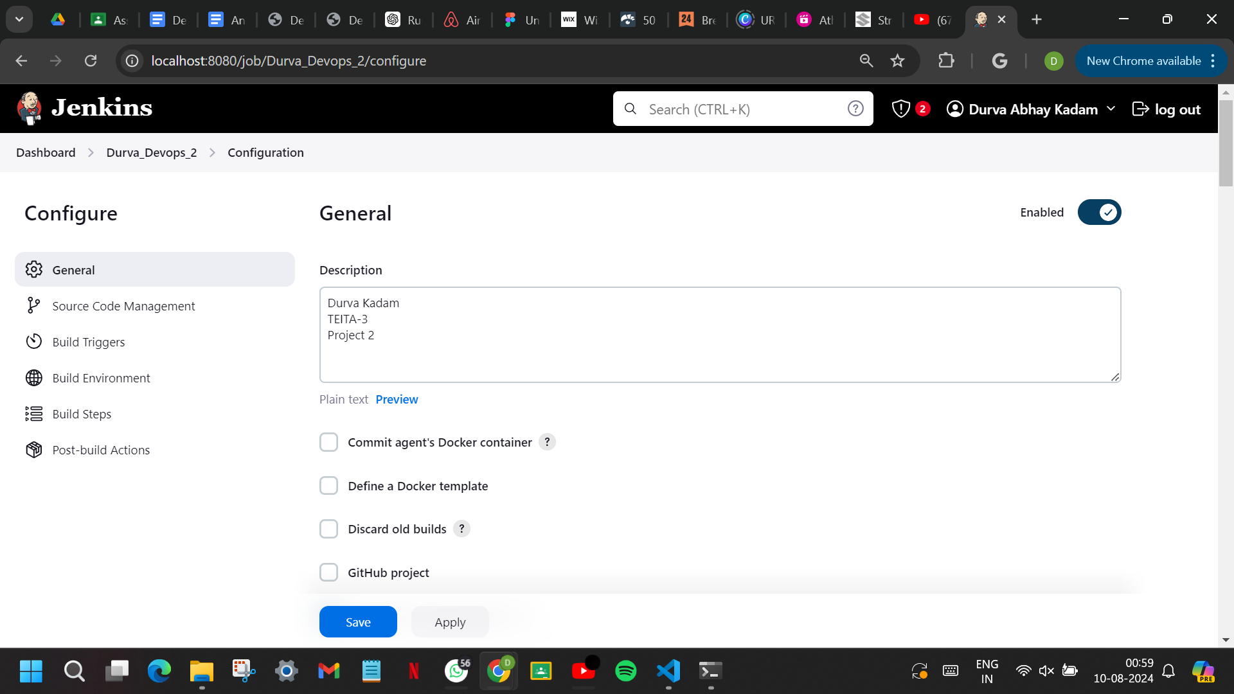

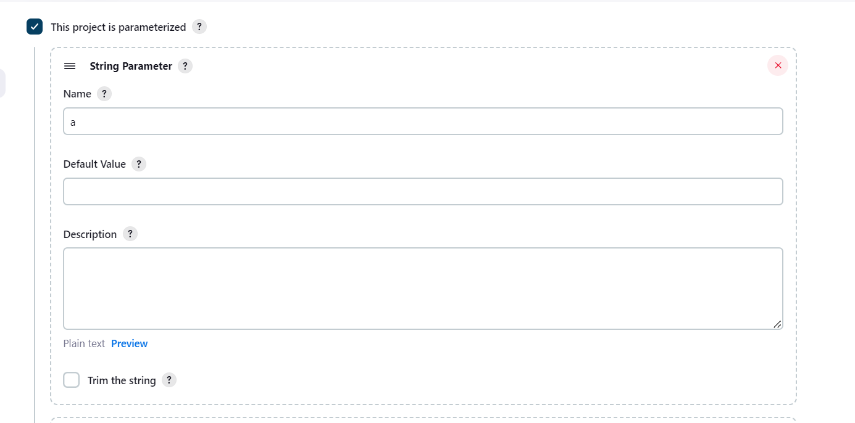

**Strings parameter:**

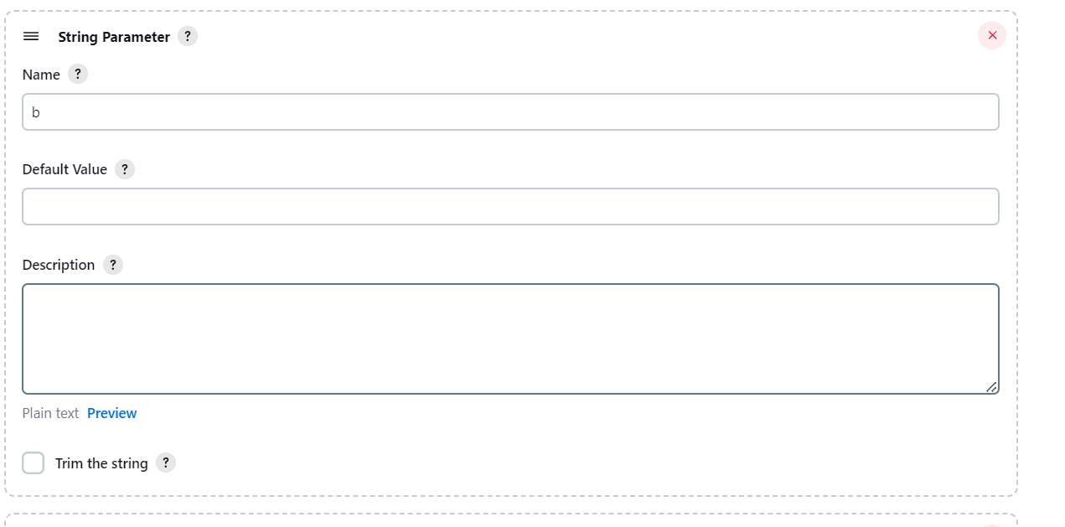

**Boolean Parameter:**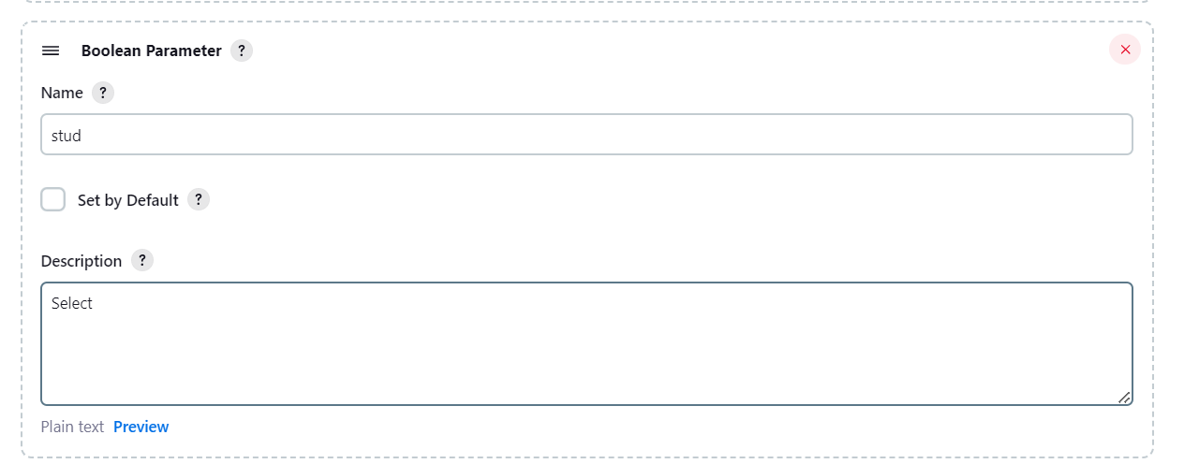

**Choice Parameter:**

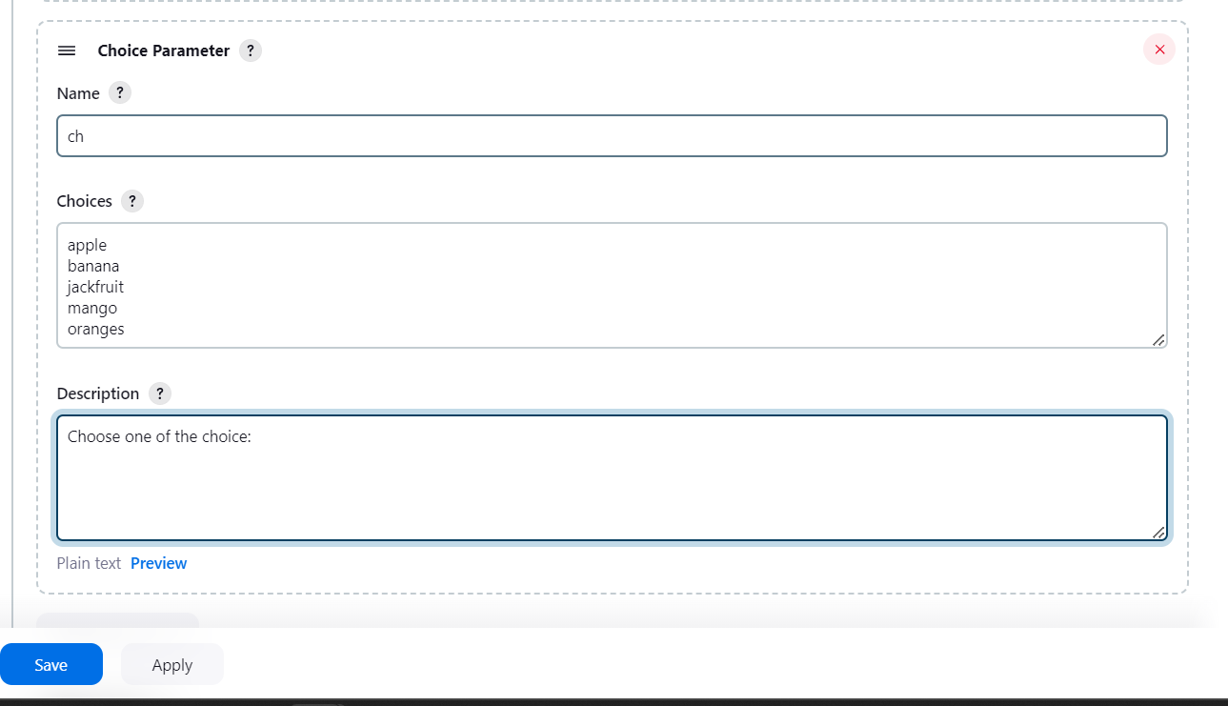

**Batch Command:**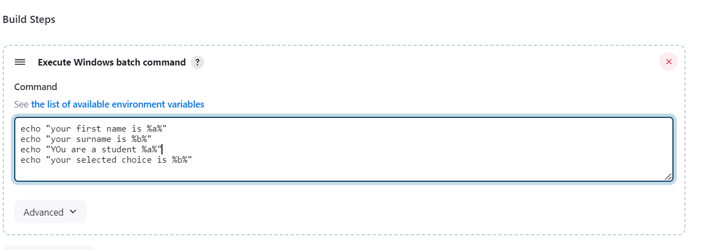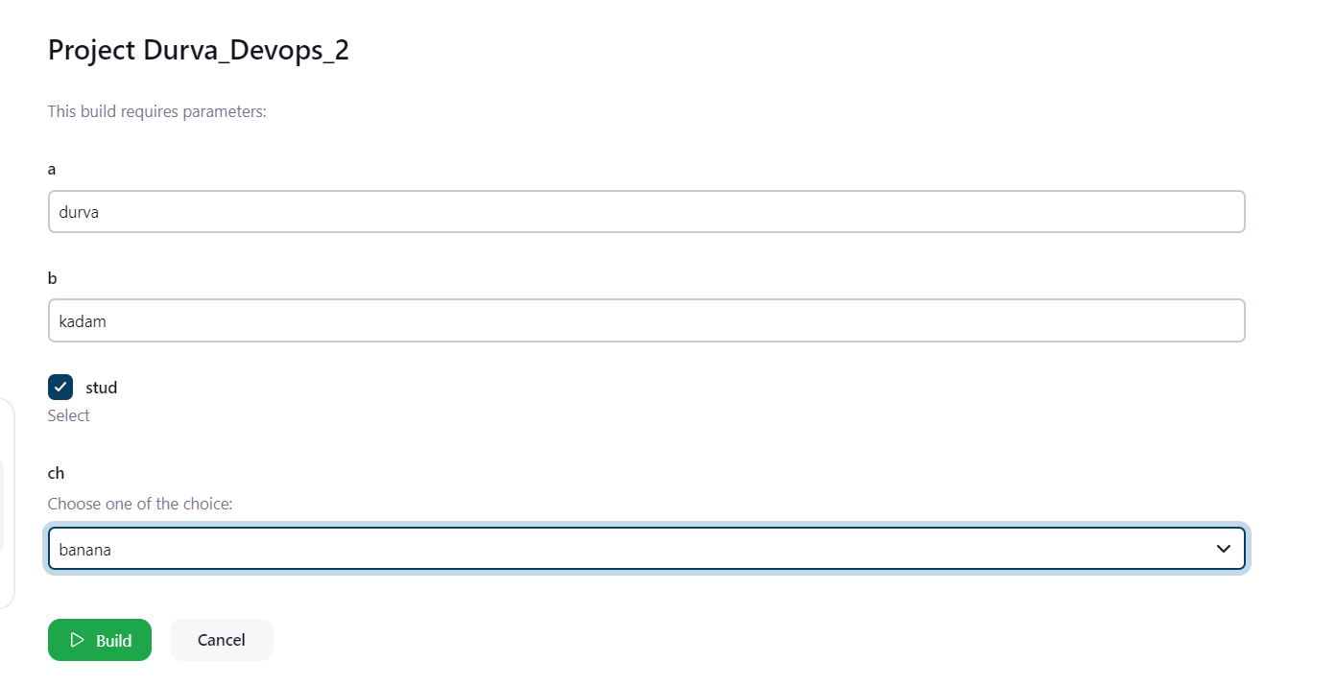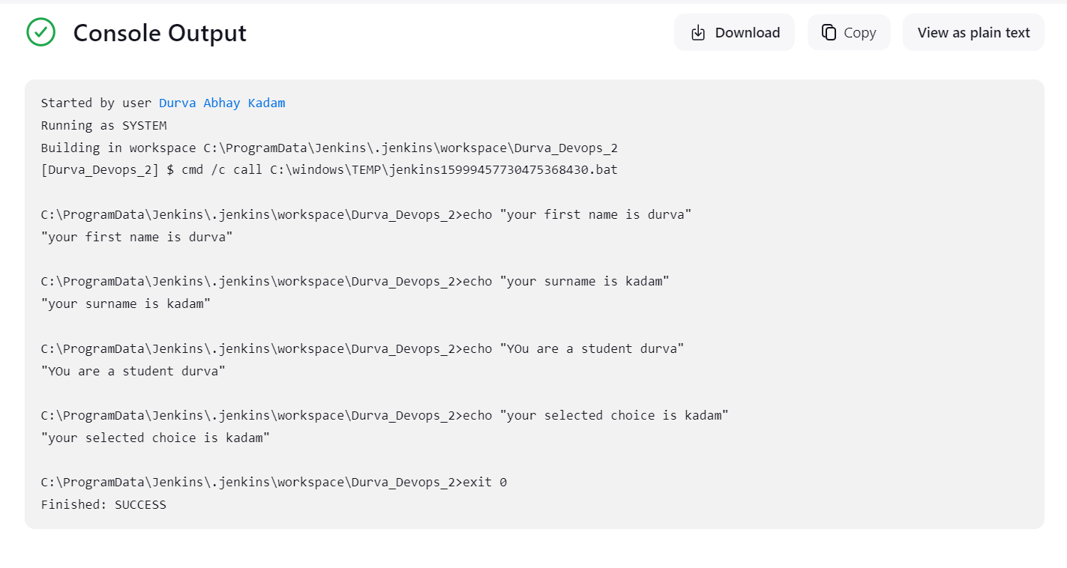

**PROJECT - 3:**

CODE:

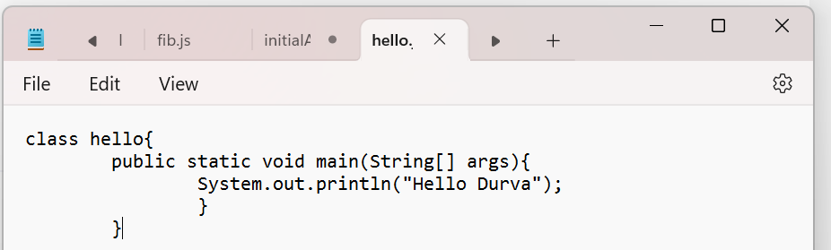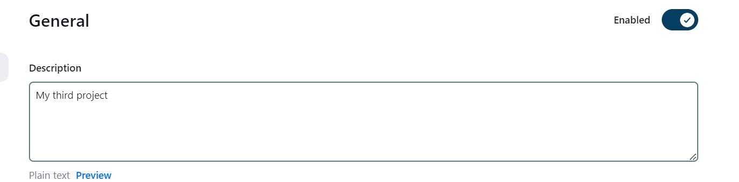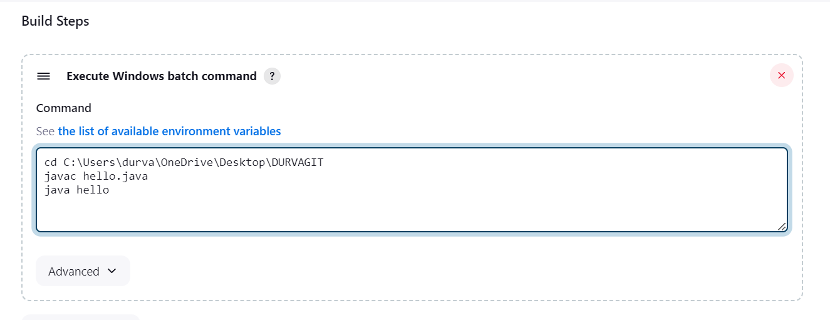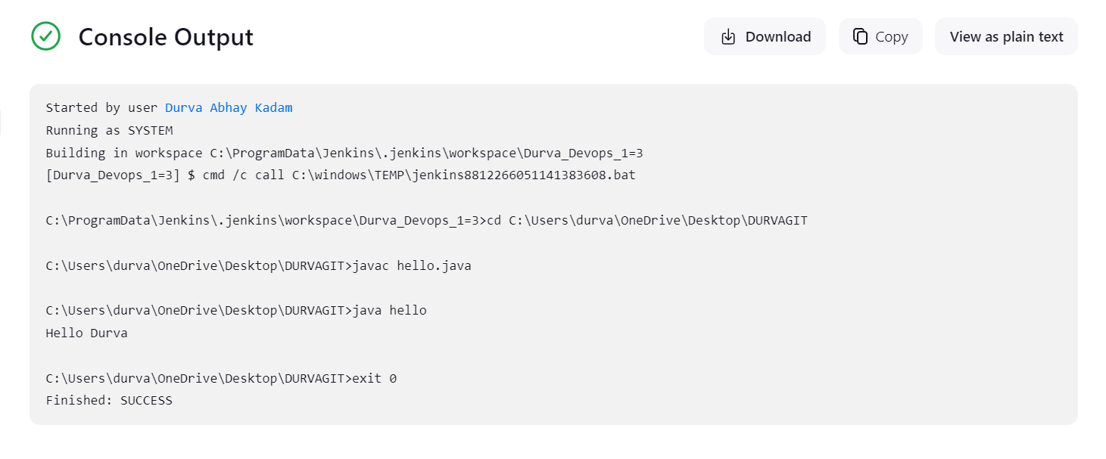

**PROJECT - 4:**

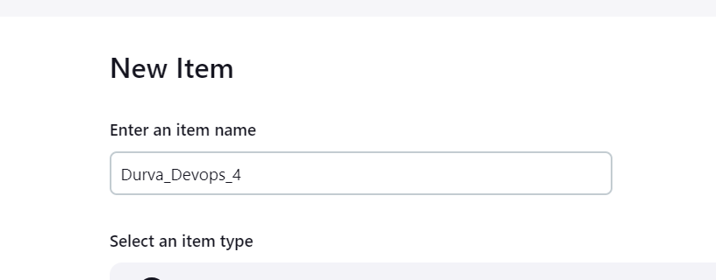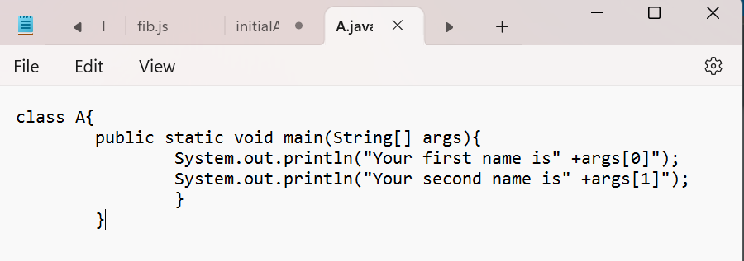

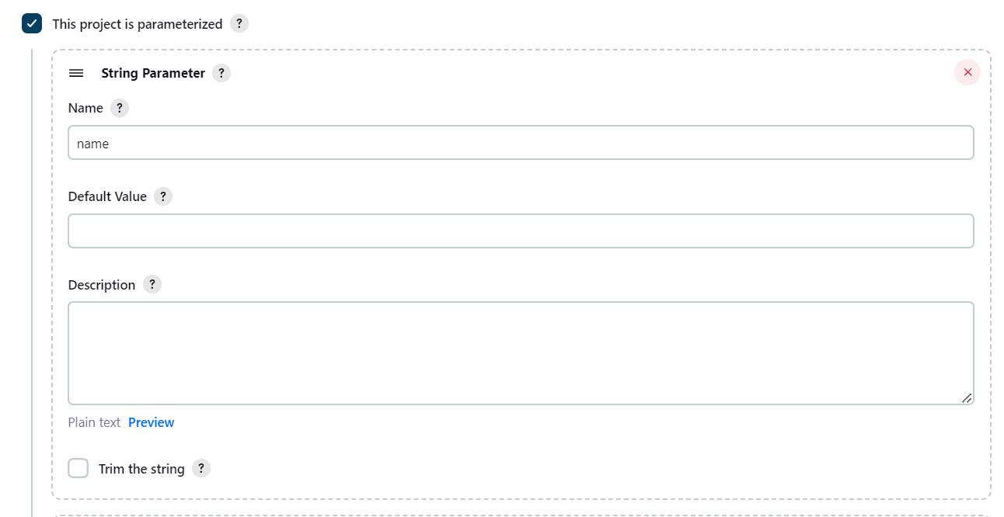

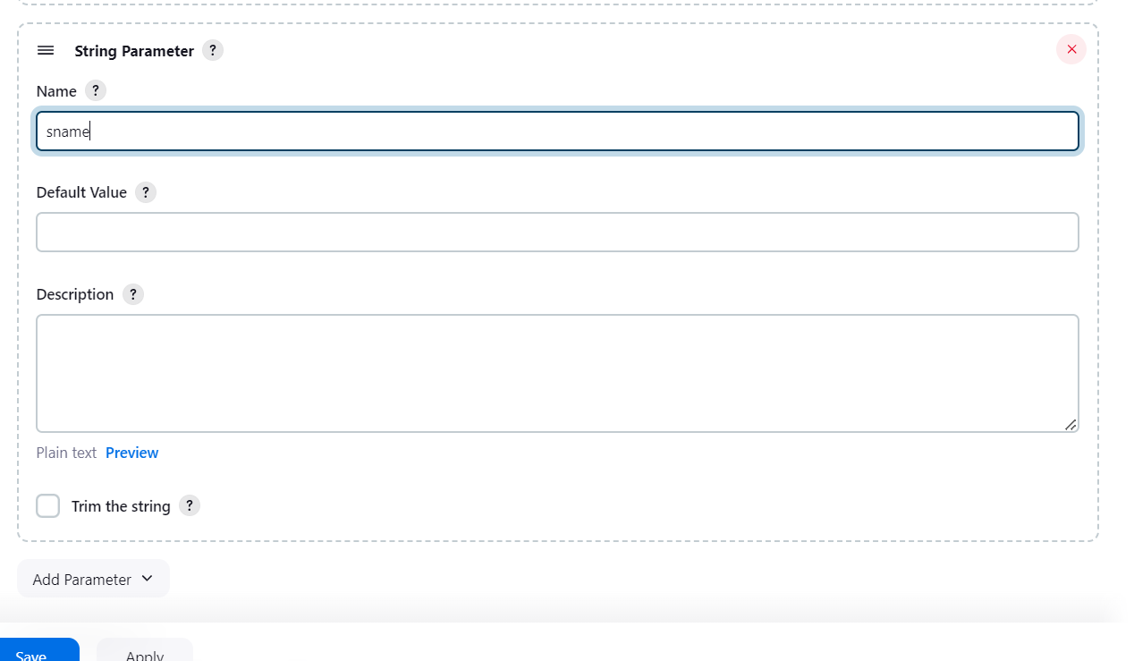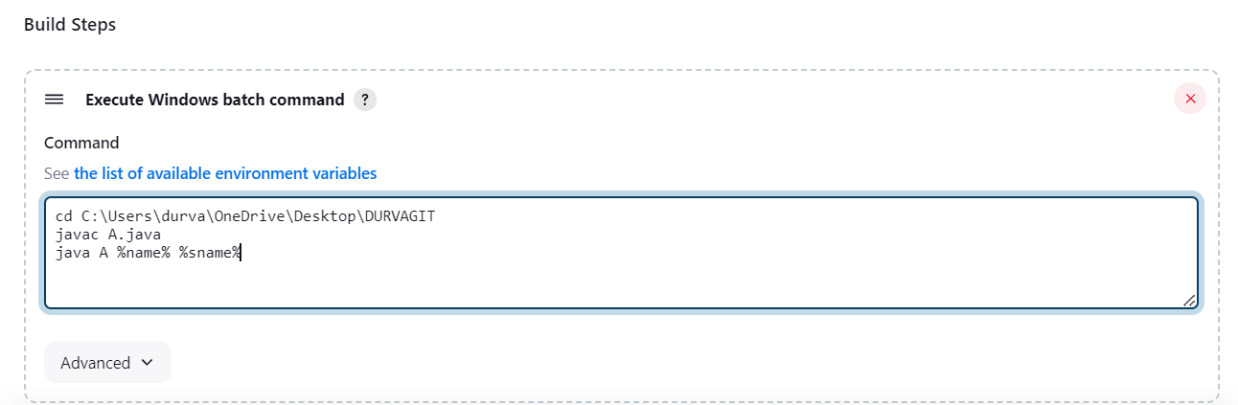

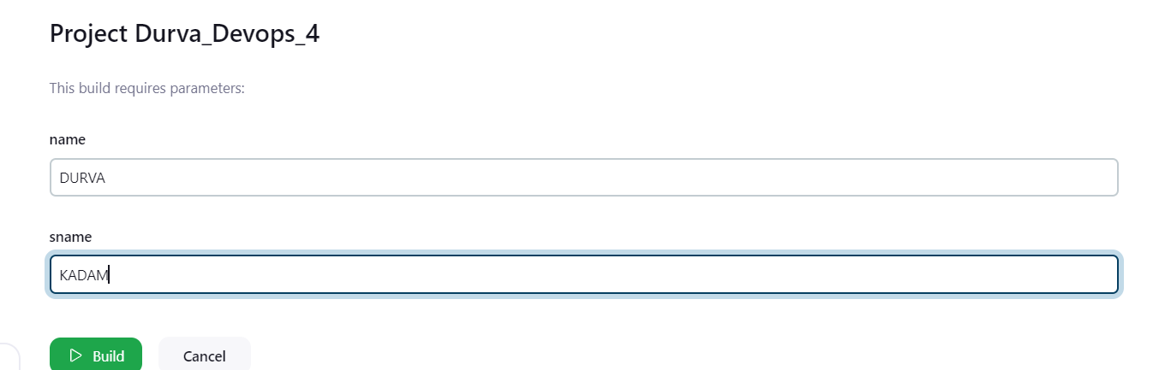

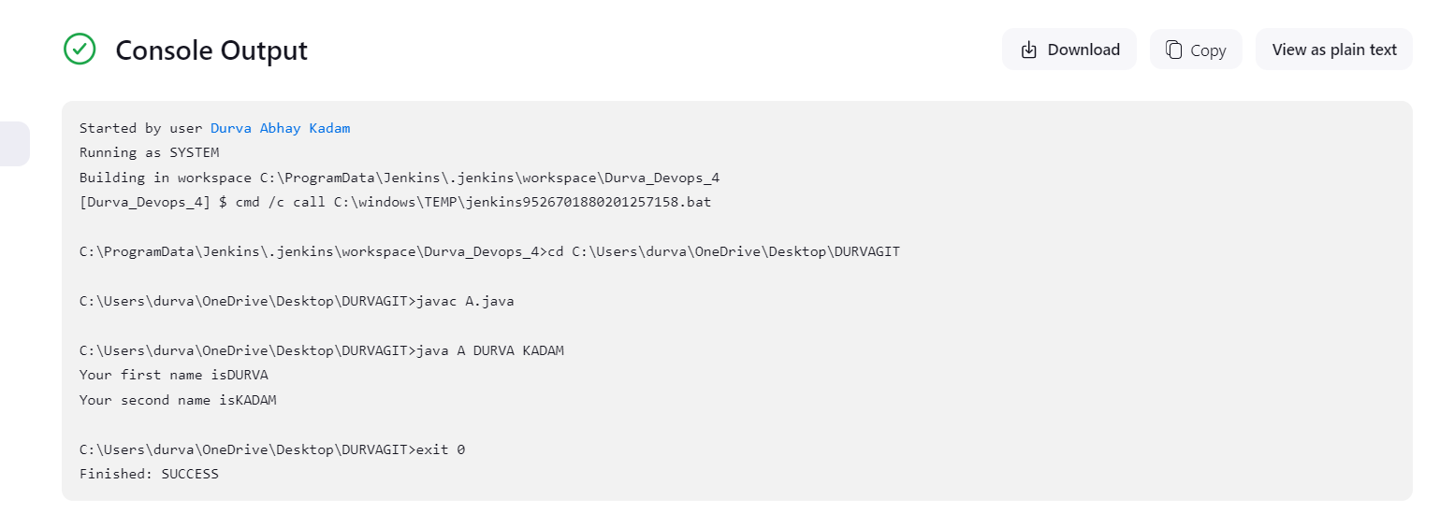

**in java with parameters**

public class javamaths {

public static void main(String[] args) {

int num1 = Integer.parseInt(args[0]);

int num2 = Integer.parseInt(args[1]);

String operation = args[2];

switch(operation) {

case "add":

System.out.println(num1 + num2);

break;

case "subtract":

System.out.println(num1 - num2);

break;

case "multiply":

System.out.println(num1 * num2);

break;

case "divide":

if(num2 != 0) {

System.out.println(num1 / num2);

} else {

System.out.println("Cannot divide by zero");

}

break;

default:

System.out.println("Invalid operation");

}

}

}

cd C:\Users\durva\OneDrive\Desktop

javac javamaths.java

java javamaths %NUM1% %NUM2% %OPERATION%

**normal praram:**

echo "Your first name is %a%"

echo "Your surname is %b%"

if "%student%"=="true" (

echo "You are a student."

) else (

echo "You are not a student."

)

echo "Your choice is %ch%"